NAME:ANNITA NKATHA AUGUSTINE
ADM NO:27737
PRACTICAL ASSESMENT 1:INSTALL MS SQL SERVER-2022 EXPRESS
TASKS
STEP 1:Download MS SQL Server Express 2022
a)Open the web browser and search for “download SQL Server Express 2022”
b)Click the official Microsoft download page
c)Click the download button and give it time do finish the process
d)Save the installer file in your folder
STEP 2 $ 3 :Launch Installer and Perform Installation
1 .Locate and double click the downloaded file to launch
2 .Choose the basic installation
3 .Accept the Microsoft license terms
4 .Choose your installation path and install

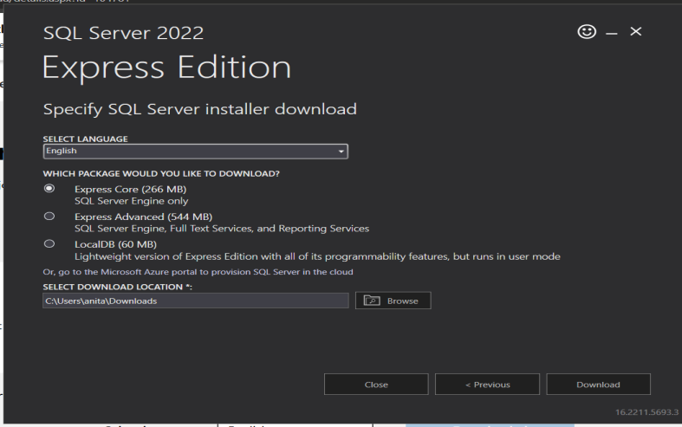

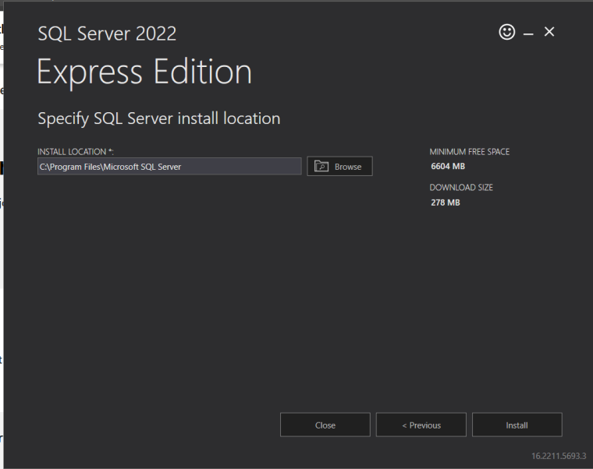
Step 4 & 5: Download & Install SSMS
- Download SSMS" in a browser
- This opens a webpage; click the link to download the latest version of SQL Server Management Studio.
- Once downloaded, open the installer file (SSMS-Setup-ENU.exe).
- Click Install and wait for the setup to finish. You may need to restart your computer.

NB: The process of installing takes a time so give it time to install
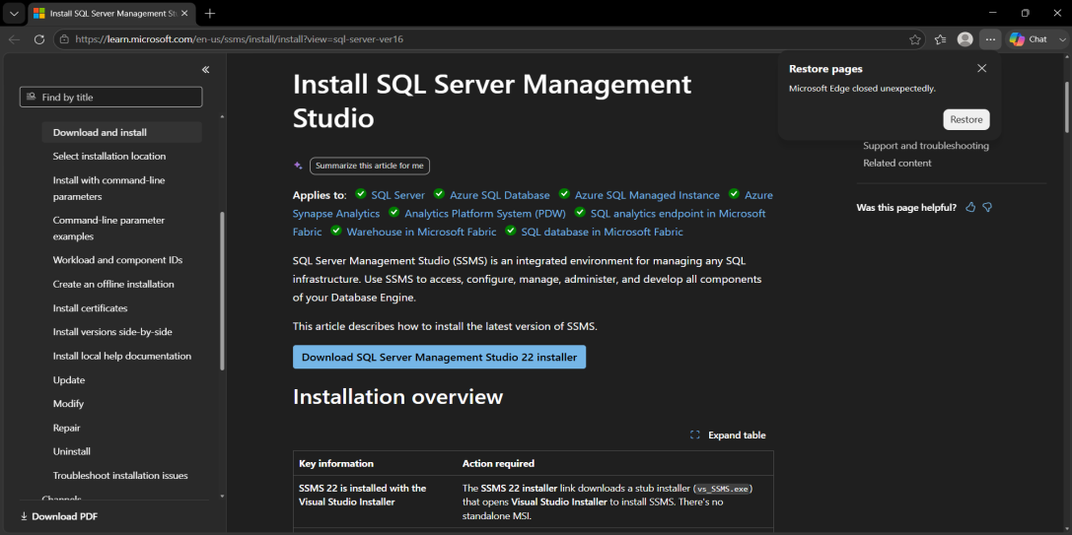

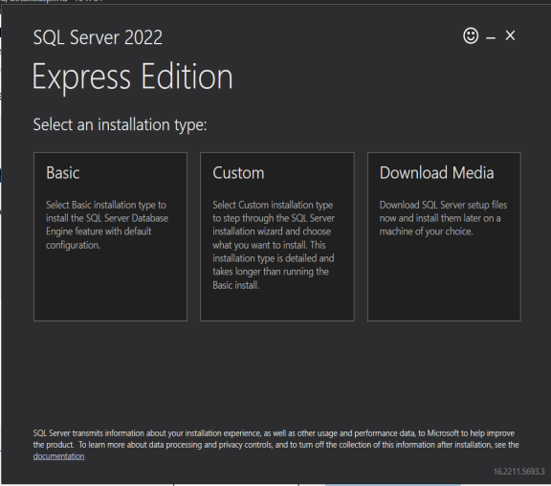

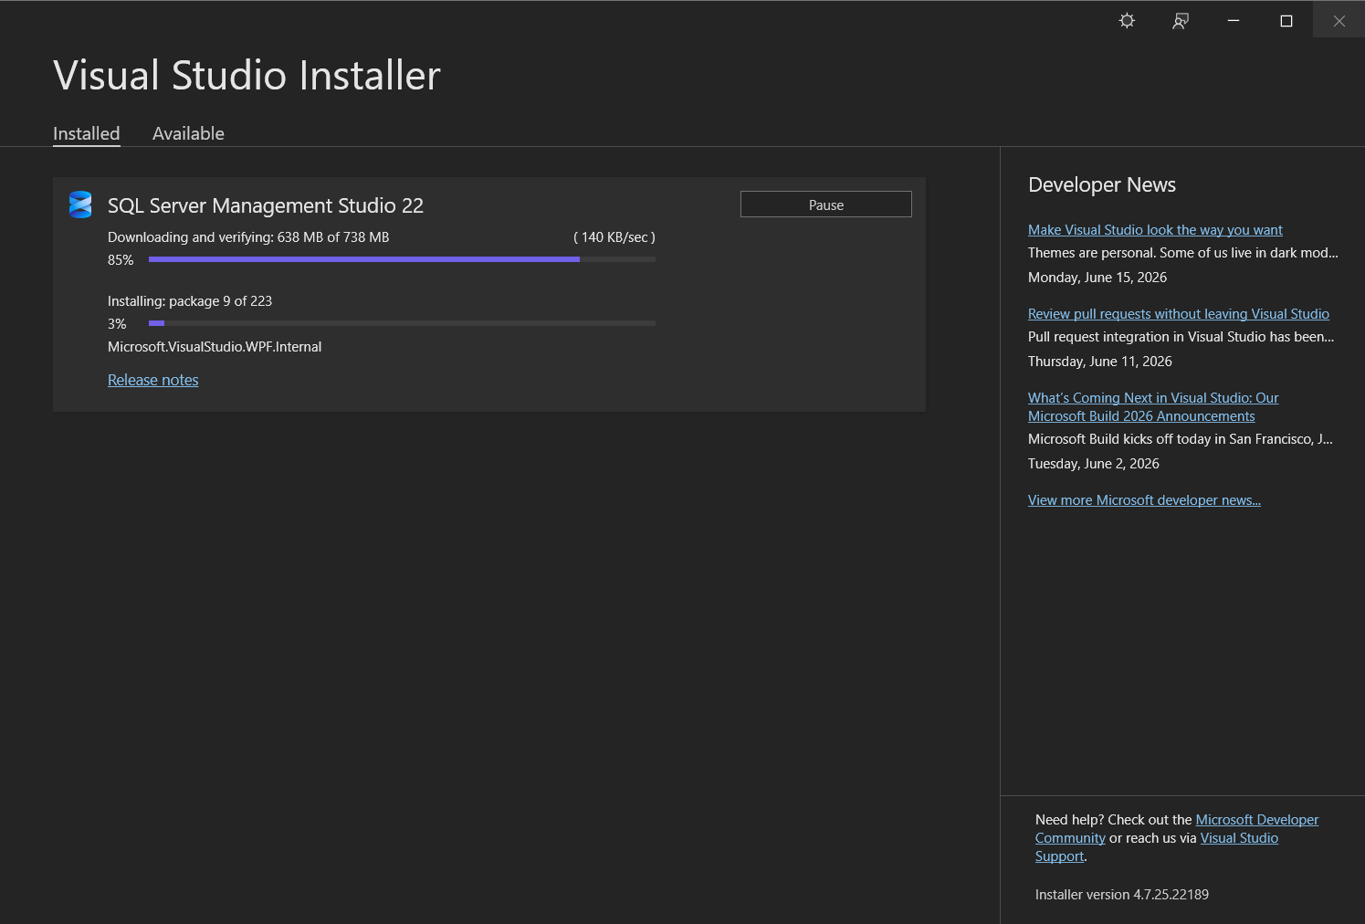
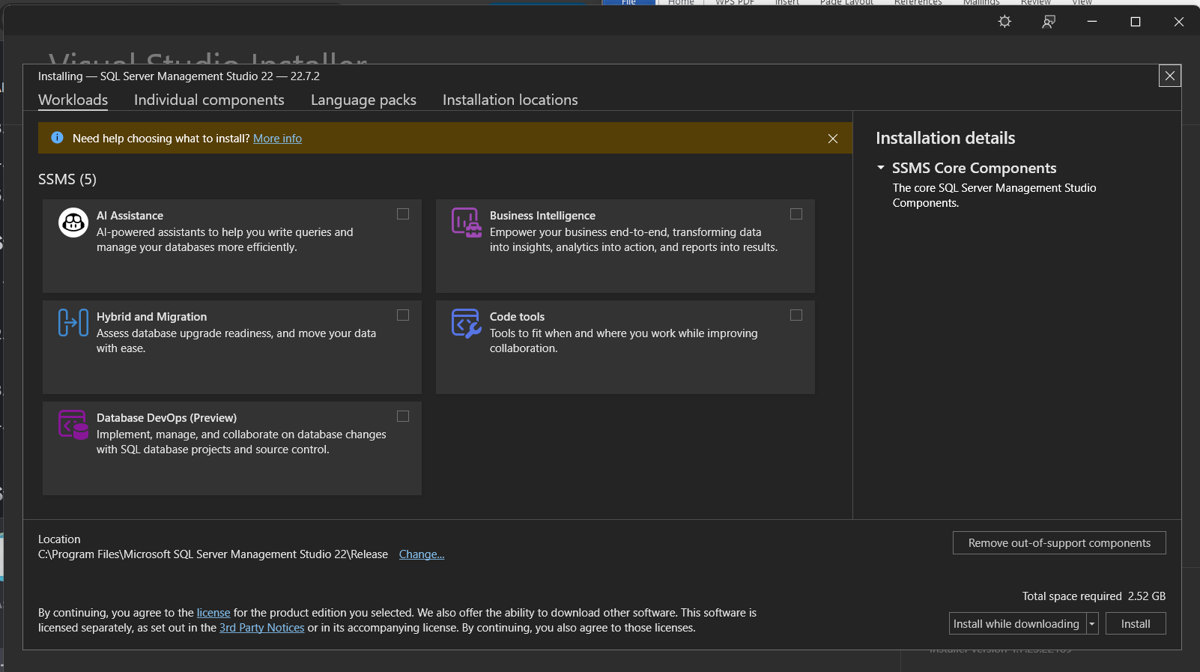

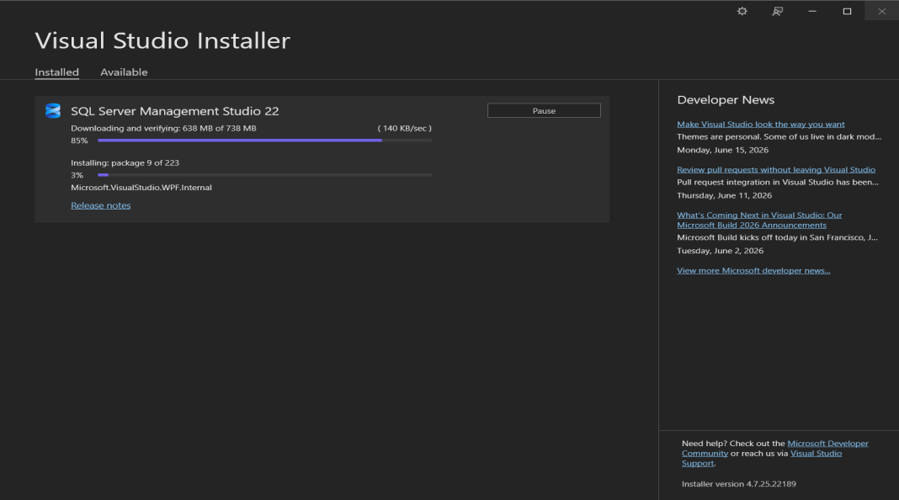

Restart the computer after it has fully downloaded to continue with step 6

Step 6: Verify Connection
- Open your Windows Start Menu, search for SQL Server Management Studio, and open it.
- In the "Connect to Server" dialog box select
>Server type: Database Engine
> Server name: localhost
>Browse for more select your local.
> Authentication: Windows Authentication
- Click Connect. If successful, your server instance will appear in the Object Explorer pane on the left.

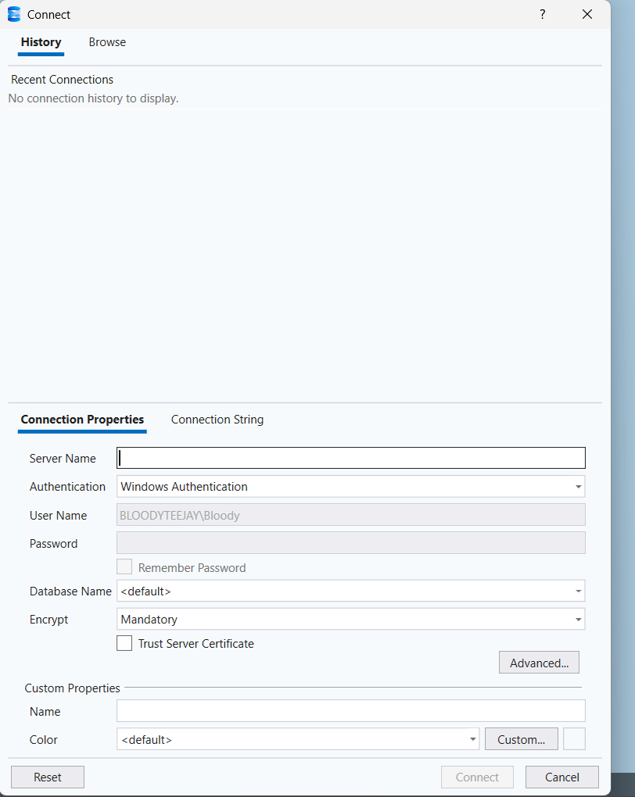

Step 7: Verify Server Components
- In the Object Explorer on the left side, look at the top item to ensure the Database Engine is running (indicated by a green play icon).
- Expand the Databases folder.
- Expand the System Databases folder.
- Confirm you see the default system databases: master, model, msdb, and tempdb.

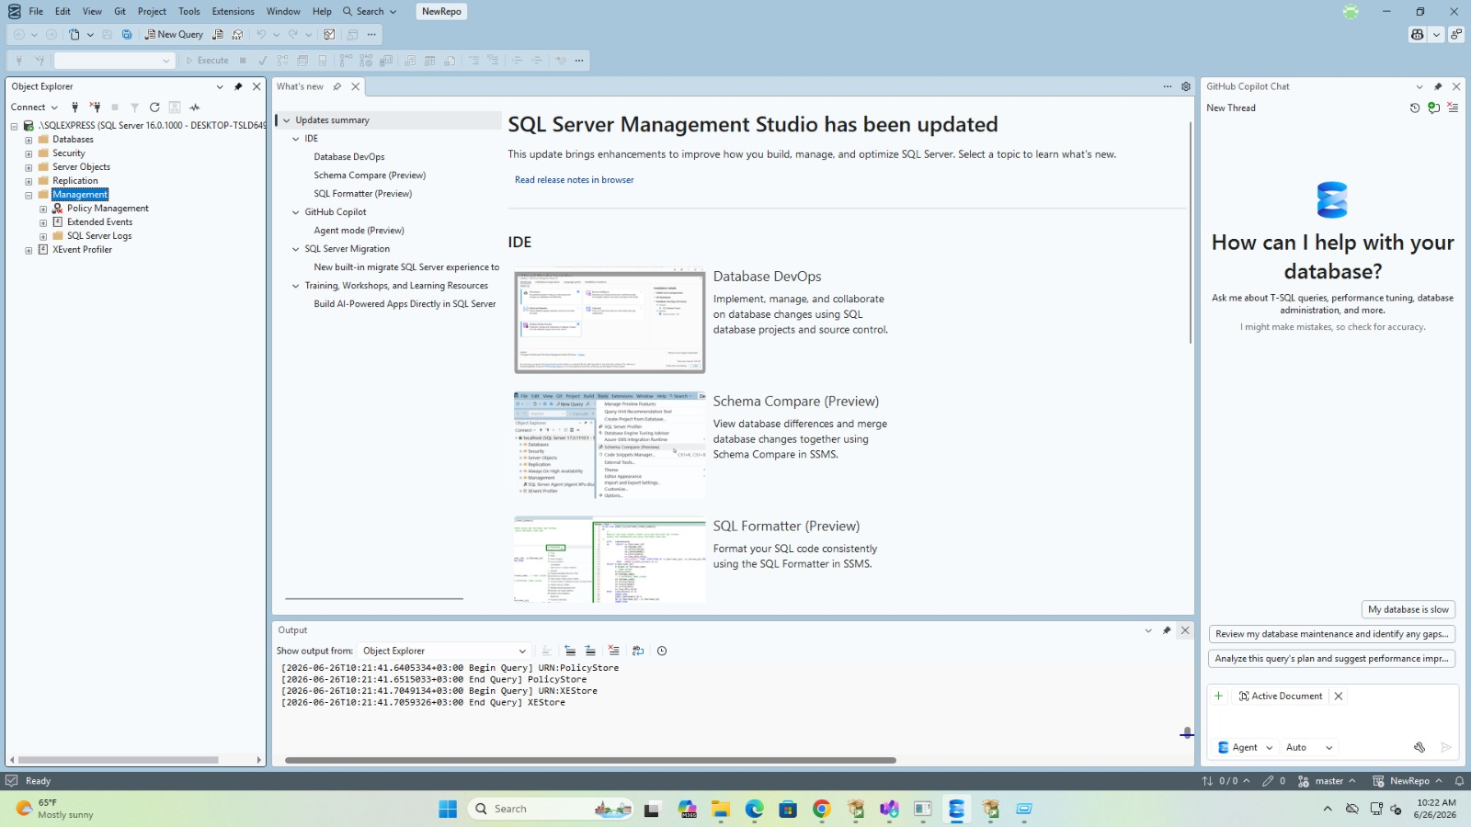

Step 8: Execute Test Query
- Click the New Query button in the top toolbar of SSMS.
- In the blank query editor window that opens, type the following exact SQL command:
sql
SELECT @@VERSION;
Use code with caution.
- Click the Execute button (or press F5 on your keyboard).
- Verify that the Results pane below displays a string starting with:
Microsoft SQL Server 2022...

